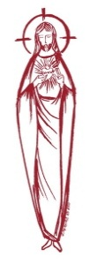**SACRED HEART PARISH**

Sacred Heart Parish Founded 1814, The First Catholic Parish in the STate of New Jersey

Sacred Heart Church, 343 South broad Street, Trenton, New Jersey 08608

Holy Cross Church, 233 Adeline Street, Trenton, New Jersey 08611

**ALL ARE WELCOME**

Whatever your present status in the Catholic Church, whatever your current family or marital situation,

Whatever your past or present religious affiliation, whatever your personal history, age, background, or

race, whatever your own self-image or esteem, you are invited, welcomed, accepted, loved and

respected at the Parish of the Sacred Heart.

**PASTOR**

Rev. Msgr. Dennis A. Apoldite

[frdennis@trentonsacredheart.org](mailto:frdennis@trentonsacredheart.org)

**PAROCHIAL VICAR**

Rev. Charles Muorah

Rev. Marcin Kania, weekend Polish Mass

**Felician Residence for Clergy**

233 Adeline Street, Trenton, New Jersey 08611

609-393-4826 ext. 108 for Fr Charles

**DEACONS**

John Grussler and Dr. Christian Nnajiofor

**Business Manager / ADMINISTRATIVE ASSISTANT**

John DeSantis: secretary@trentonsacredheart.org

**coordinator of religious education**

Mary Tovar: reled@trentonsacredheart.org

**COORDINATORS OF SACRED MUSIC**

Natalie Megules ~ 609-575-6484

Rupert Peters ~ Gospel Mass 609-442-7871

**MAINTENANCE DEPARTMENT**

Frank Rios

**Trustees**

Jack Breuer and Ellieen Ancrum Ingbritsen,

**OFFICE HOURS**

9:00am – 4:00pm Monday – Friday

**SACRED HEART PARISH OFFICE**

343 South Broad Street, Trenton, NJ 08608

**Phone: (609) 393-2801 ~ Fax: (609) 989-8997**

**WEB PAGE:**

www.trentonsacredheart.org

**CEMETERY RECORDS**

Contact The Office of Catholic Cemeteries at 609-394-2017 or DirectorofCemeteries@DioceseofTrenton.org

**SACRAMENTAL RECORDS**

Sacred Heart Church, Saint John’s Church, Saint Francis Church, Saints Peter and Paul Church, Saint Stanislaus Church, Holy Cross Church, Blessed Sacrament Church, Our Lady of Divine Shepherd Church, Blessed Sacrament/Our Lady of Divine Shepherd Parish and Divine Mercy Parish.

**Liturgy Schedule**

**Sacred Heart**

Monday, Tuesday, Wednesday and Friday

12:10 Noon

Saturday Evening 5:15 PM

Sunday Morning 9:00 and 11:15 AM

**HOLY CROSS**

Monday, Thursday and Friday 8:00 AM

First Friday 6:30 PM Polish Mass

Saturday Evening 4:00 PM

Sunday Morning 10:00 AM Gospel

12:00 Noon Polish

For each Holy Day please reference the bulletin

**SACRAMENTS**

**BAPTISM**

Please call the Parish Office at least one month in advance.

**RECONCILIATION**

Every First Friday following the 12:10PM Mass SHC

Saturday afternoon ~ 4:30 to 5:00 PM SHC

Every Saturday from 3:30 to 3:50 PM HCC

Every Sunday 9:30 to 9:50AM HCC

and by appointment.

**EUCHARISTIC ADORATION**

First Saturday of the Month 2:30 to 3:30 pm

in Holy Cross Church

**MARRIAGE**

Please call the Parish Priest at least one year in advance to set up initial meeting and to confirm a wedding

date and time.

**ANOINTING OF THE SICK**

Please call the Priests any time 609-393-2801.

**COMMUNION TO THE HOMEBOUND**

Call the Parish Office to schedule home visit.

**CONSIDERING PRIESTHOOD?**

Email: [Vocations@DioceseofTrenton.org](mailto:Vocations@DioceseofTrenton.org)

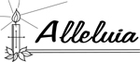

**Fourth Sunday of Easter**

**Good Shepherd Sunday**

**April 30, 2023**

**MASS INTENTIONS**

**Saturday, April 29**

**10:00 am SHC First Communion**

4:00 pm ~ Vilma Mathews

5:15 pm SHC ~ Special Intention

**Sunday, April 30**

9:00 SHC ~ Hoch and Ridorfino Family

10:00 HCC ~ Rev. Anthony M. Kramarz

11:15 SHC ~ Helen Potash

12:00 HCC Polish ~ The People of the Parish

**Monday, May 1**

8:00 am HCC ~ Marie Cracker Feyl

12:10pm SHC ~ Carl Amoroso

**Tuesday, May 2**

12:10 pm SHC ~ Ann Amoroso Kostura

**Wednesday, May 3**

12:10 pm SHC ~ Maria Tagliaferri

**Thursday, May 4**

8:00 am HCC ~ Diana Cracker Amoroso

**Friday, May 5**

8:00 am HCC ~ Eileen Kostrzewa

12:10pm SHC ~ Ronald Bodnar

**Saturday, May 6**

4:00 pm ~ Dolores Krysztofik

5:15 pm SHC ~ Ken and Lucille Fisher

and Special Intentions

**Sunday, May 7**

9:00 SHC ~ Altar Rosary Society

10:00 HCC ~ The People of the Parish

11:15 SHC ~ Pat Tagliaferri

12:00 HCC Polish ~ Malgorzata Gawron

**OUR SICK LIST**

Paul Wilczynski, Dan Breese Jr, Brenna Kennedy-Moore, Dawn Chia, Chris Heulitt, Mark Friedman, Robert Leighton, Patrick Leighton, Alexander A. Ladnyk, Kelly Nitti, Lauren Clayton, Joseph Edralin, Margie Tiongson, Kevin, Vincent Cooper, Jr., Gail Ladnyk, Leo Genovesi, Sloane Donnelly, Richard Buckley, Tony Ragolia, Barbara Burrows, John Matthews, Pam Yuhas, Robert Mahon, Charles Burrows, Dorothy Amoroso, Maryann Sullivan, Regina Friedman, Rita Mich, Stanley Winowicz, Greg Schafer, Jack Hardiman, Paul Leighton, Amy Birk, Julia Grazioli, Matt and Leona Tydryszewski.

**OUR DECEASED**

Deacon John Grussler, Pat Tagliaferri, and our friends at South Village, Riverside Nursing and Rehabilitation Center, Mill House and Waters Edge.

**MINISTRY SCHEDULE**

**Saturday, April 29**

4:00pm HCC ~ Msgr. Dennis L. F Zielinski Em. E Zielinski

5:15pm SHC ~ Msgr. Dennis L. L Bellina EM. B DuMont & T Hines

**Sunday, April 30**

9:00 SHC ~ Msgr. Dennis L.R Haynes Em H&M Figueroa

10:00 HCC ~ Msgr. Dennis L I Nwachukwu EM Q Hilton

11:15 SHC ~ Msgr. Dennis L. M. Rhodes Em K. Myers, E. Wirzburger

12:30 HCC Polish ~ Fr. Marcin L.

**Saturday, May 6**

4:00pm HCC ~ Fr Charles L. V Zielinski Em. L Bliznawiczus

5:15pm SHC ~ Msgr. Dennis L. R Hernandez EM. M Salamandra & A Solack

`**Sunday, May 7**

9:00 SHC ~ FR. Charles L. Y Laurenti Em R & K Figueroa

10:00 HCC ~ Fr. Charles L M Williams EM F Kollie

11:15 SHC ~ Msgr. Dennis L. B. Allaire Em L.&J. Bautz

**12:30 HCC Polish ~ Fr.**

**WEEKLY COLLECTION**

Last weekend’s collection amounted to $7.321.00. This includes the donations received in Church and the mail ins. Thank you for your continued support of our parish.

**2023 ANNUAL CATHOLIC APPEAL UPDATE**

Goal: $33,000.00

Pledged: $38,056.00 (115% of Goal)

**READINGS FOR THE WEEK**

**Fourth Week of Easter   
Sunday** Acts 2:14a, 36-41; 1 Pt 2:20b-25; Jn 10:1-10

**Monday** Acts 11:1-18; Jn 10:11-18

**Tuesday** Acts 11:19-26; Jn 10:22-30

**Wednesday** 1 Cor 15:1-8; Jn 14:6-14

**Thursday** Acts 13:13-25; Jn 13:16-20

**First Friday** Acts 13:26-33; Jn 14:1-6

**Saturday** Acts 13:44-52; Jn 14:7-14

**PROMISE TO PROTECT**

The Diocese of Trenton is committed to the norms of the U.S. Bishop’s Charter for the Protection of Children and Young People in regard to the reporting and investigation of sexual abuse allegations involving minors. If you have been sexually abused as a minor by anyone representing the Catholic Church, you can report that abuse through the diocesan Hotline: 1-888-296-2965 or via e-mail at [abuseline@dioceseoftrenton.org](mailto:abuseline@dioceseoftrenton.org). Allegations are reported to the appropriate law enforcement agencies.

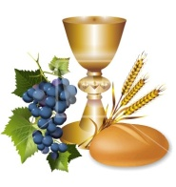

We welcome our First Communicants to the Table of the Lord

Manu Barwuah

Yaw Barwuah

Grant Bocka

Angeline Campos

Orazia Caserta

Antonio Colon-Molnar

Kainoa Daikawa

Angelina DeGarmo

Andrew DeLeon

Ayden Deleon

Thiago Deleon

Deacheng Freeman

Anthony Santos Jimenez Gonzalez

Jeancarlo Jimenez Gonzalez

Patrick McGillivary

Karen Montoya Luna

Avalyn Pienciak

Dominic Runof

Constantina Toe

Vincent Vagnozzi

Maxim Wirzburger

Sean Zielinski

Our prayerful congratulations to the children of our parish who celebrate their First Holy Communion

this weekend.



**MOTHER’S DAY**

**SPIRITUAL REMEMBERANCE CARDS**

The Mother’s day Spiritual Mass cards are available in the vestibule of the Church. Please take as many as you need and return so they can be placed on the altar.

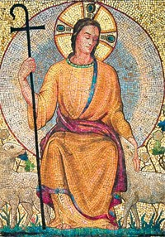

**WORLD DAY OF PRAYER FOR VOCATIONS**

World Day of Prayer for Vocations is being observed this weekend, Saturday and Sunday, April 29-30, 2023 also known as "Good Shepherd Sunday."  The purpose of this day is to publicly fulfill the Lord's instruction to, "Pray the Lord of the harvest to send laborers into his harvest" (Mt 9:38; Lk 10:2).  Please pray that young men and women hear and respond generously to the Lord's call to the priesthood, diaconate, religious life --- especially religious orders serving in our Diocese and societies of apostolic life or secular institutes.

**VOCATION PRAYER**

Lord Jesus, Son of the Eternal Father and Mary Immaculate, give to our young people the generosity necessary to follow Your call and the courage required to overcome all obstacles to their vocation. Give to parents that faith, love and spirit of sacrifice which will inspire them to offer their children to God's service and to rejoice whenever one of their children is called to the priesthood or religious life. May Your example and that of Your Blessed Mother and Saint Joseph encourage both young people and parents and let Your grace sustain them. Amen.

**MAY CROWNING**

Please join us for the annual May Crowning of the image of the Blessed Virgin Mary next Sunday following the 11:15am Mass. The procession will be led by our First Communicants and the children of the parish to the outdoor statue of Our Lady in front of the school building.

**FATHER MARCIN KANIA**

It is with mixed emotions that we announce that Fr. Marcin, our celebrant for the Sunday Polish Mass, has been assigned as temporary administrator of Saint Jerome Parish in Long Branch, NJ effective May 1, 2023. Fr. Marcin has been a wonderful asset to our parish over the past few years and has taken care of the Spiritual needs of our Polish community. He will be sorely missed and yet at the same time we are thrilled that Fr. Marcin is being recognized for his capability as he assumes this new responsibility.

We have been working on finding a Polish priest to continue our weekly Polish Sunday Mass at 12:00 Noon but we are experiencing great difficulty. We will continue to have that Mass on the schedule.

**RELIGIOUS EDUCATION NEWS**

**RE-REGISTRATION**

Parents are asked to reregister their children on or before the last class. Re-registration forms are available online or from Mary Tovar. The tuition fee is $65.00 per child.

**NEW REGISTRATIONS ACCEPTED**

Parents who have children beginning their Religious Education are asked to register as soon as possible. You can obtain the form on our web page or by calling the parish office.

**COMMUNION AND CONFIRMATION CLASS**

If you have a child who is ready to make his or her First Communion or Confirmation, the Diocesan guideline requirement is that they complete two years of Religious Education. For First Communion your child must attend First and Second year of Religious Ed and for Confirmation the child must complete grade 7 and 8 before receiving the Sacrament of Confirmation. Please be sure to register soon.

**SACRAMNET OF CONFIRMATION**

You are also invited to attend the Ceremony for the Sacrament of Confirmation to be administered on May 9, 2022 at 6:00 pm.

**ALTAR ROSARY SOCIETY**

All rosarians, future rosarians, people of the parish are warmly welcomed to join us on Sunday, May 7th, 9:00am Mass at Sacred Heart Church. The rosary will be prayed before Mass. Following Mass, a meeting will take place at Toomey Hall. Stop by, meet the members and enjoy light refreshments. We are a church support group of dedicated Catholic people who serve our Blessed Mother our Parish. Hear about the good the Rosarians do for our parish community. God Bless you all. We are looking forward to your participation. Any questions, please call Joan Buckley @ 609-396-7063.

**IT’S TIME TO PLAY BALL**

The Sacred Heart Holy Name is sponsoring its 9th Annual Nite AT TRENTON THUNDERon Thursday, June 15th at 7:00 p.m. when the Trenton Thunder will take on the *STATE COLLEGE SPIKES*.  We have reserved a limited number of seats in the COVERED Picnic area, so rain or shine you will stay dry and cool.  And for only $28 per person you receive a game ticket and have access to a delicious 90 minute (6:30 – 8:00) all you can eat picnic buffet of hot dogs, chicken, hamburgers, cheese burgers, veggie burgers, potato salad, garden salad, baked beans, chips, cookies, bottled water and soda. There will be prizes and games. There will be fireworks after the game. Tickets must be paid for by May 14th so reserve your seat now!  Please contact Dave Rimili at 609-424-9677to reserve your seat.

**THE EUCHARISTIC MIRACLES**

Blessed Carlo Acutis is the first millennial to be beatified, and he lived until he was only 15 years old. His interests in soccer, swimming, and computers are relatable to our students, and because he was close in age to our middle schoolers, they are curious about how he is on the pathway to sainthood at such a young age. He is a role model for all, not only the students, because of his devotion to the Rosary, Mary, and the Holy Eucharist. The Eucharistic Miracle Exhibit will be on display from May 1 to May 15 at Our Lady of Sorrows in Hamilton, NJ. Contact the Parish Office at Fax: 609-587- 4372 or Email: [info@ols-sa.org](mailto:info@ols-sa.org) .

**FEAST OF SAINT JOSEPH THE WORKER ~ May 1**



To foster deep devotion to Saint Joseph among Catholics, and in response to the “May Day” celebrations for workers sponsored by Communists, Pope Pius XII instituted the feast of Saint Joseph the Worker in 1955. This feast extends the long relationship between Joseph and the cause of workers in both Catholic faith and devotion. Beginning in the Book of Genesis, the dignity of human work has long been celebrated as a participation in the creative work of God. By work, humankind both fulfills the command found in Genesis to care for the earth (Gn 2:15) and to be productive in their labors. Saint Joseph, the carpenter and foster father of Jesus, is but one example of the holiness of human labor.

Jesus, too, was a carpenter. He learned the trade from Saint Joseph and spent his early adult years working side-by-side in Joseph’s carpentry shop before leaving to pursue his ministry as preacher and healer. In his encyclical *Laborem Exercens,*Pope John Paul II stated: “the Church considers it her task always to call attention to the dignity and rights of those who work, to condemn situations in which that dignity and those rights are violated, and to help to guide [social] changes so as to ensure authentic progress by man and society.”

Saint Joseph is held up as a model of such work. Pius XII emphasized this when he said, “The spirit flows to you and to all men from the heart of the God-man, Savior of the world, but certainly, no worker was ever more completely and profoundly penetrated by it than the foster father of Jesus, who lived with Him in closest intimacy and community of family life and work.”

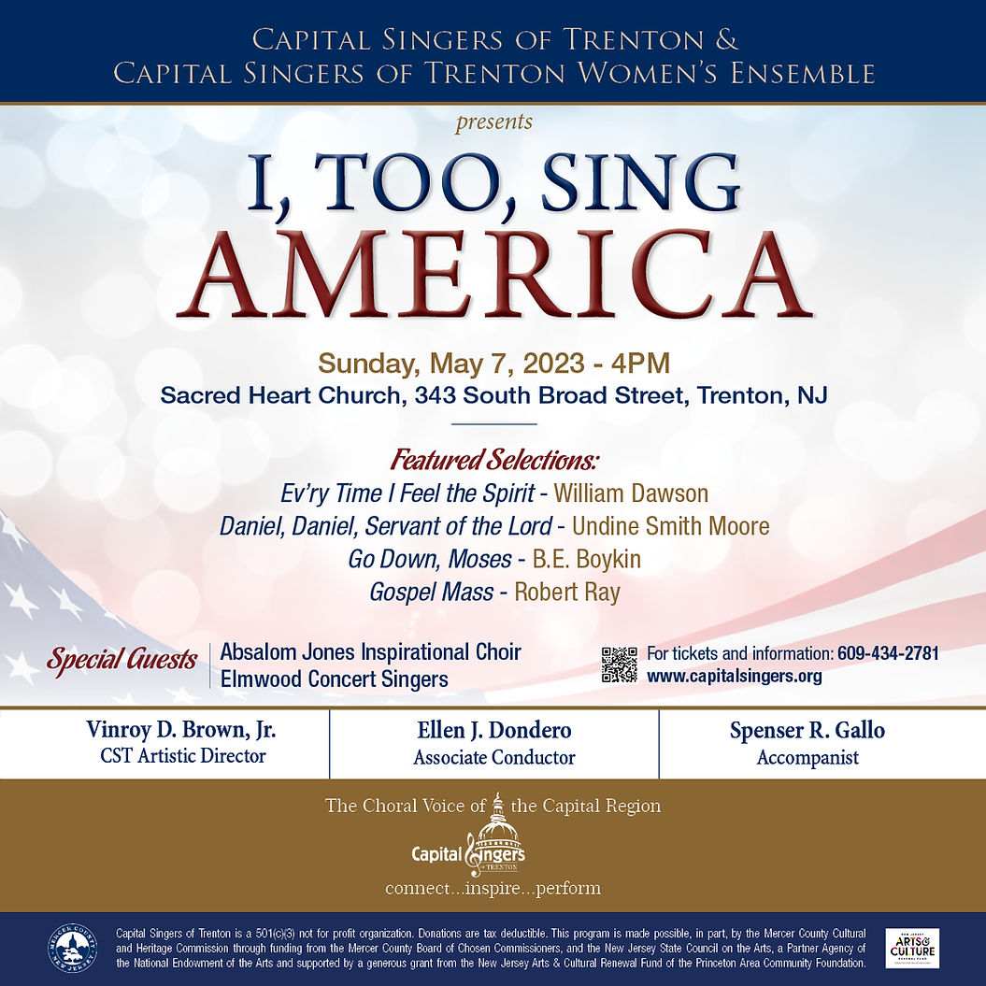

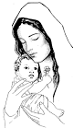

**HOW TO PRAY THE ROSARY**

1. Make the Sign of the Cross and say the “Apostles’ Creed.” 2. Say the “Our Father.” 3. Say three “Hail Mary’s.” 4. Say the “Glory Be.” 5. Announce the First Mystery; then say the “Our Father.” 6. Say ten “Hail Mary’s,” while meditating on the Mystery. 7. Say the “Glory Be,” 8. Announce the Second Mystery; then say the “Our Father.” Repeat 6 and 7 and continue with Third, Fourth and Fifth Mysteries in the same manner. 9. Say the “Hail Holy Queen.”

In the name of the Father and of the Son and of the Holy Spirit. Amen.

**Apostles’ Creed**

I believe in God, the Father almighty, Creator of heaven and earth, and in Jesus Christ, his only Son, our Lord, who was conceived by the Holy Spirit,

born of the Virgin Mary, suffered under Pontius Pilate, was crucified, died and was buried; he descended into hell; on the third day he rose again from the dead; he ascended into heaven, and is seated at the right hand of God the Father almighty; from there he will come to judge the living and the dead. I believe in the Holy Spirit, the holy catholic Church, the communion of saints, the forgiveness of sins, the resurrection of the body, and life everlasting. Amen.

**Our Father** Our Father, who art in heaven, hallowed be Thy name, Thy kingdom come, Thy will be done, on earth as it is in heaven. Give us this day our daily bread, and forgive us our trespasses as we forgive those who trespass against us, and lead us not into temptation, but deliver us from evil. Amen.

**Hail Mary** Hail Mary, full of grace, the Lord is with thee; blessed art thou among women, and blessed is the fruit of thy womb, Jesus. Holy Mary, Mother of God, pray for us sinners, now and at the hour of our death. Amen.

**Glory Be** Glory be to the Father, and to the Son, and to the Holy Spirit. As it was in the beginning, is now, and ever shall be, world without end. Amen.

**Hail Holy Queen** Hail Holy Queen, Mother of mercy! Hail, our life, our sweetness and our hope! To you do we cry, poor banished children of Eve; to you do we send up our sighs, mourning and weeping in this valley of tears! Turn then, most gracious advocate, our eyes of mercy toward us; and after this, our exile, show unto us the blessed fruit of your womb, Jesus. O clement, O loving, O sweet Virgin Mary! V. Pray for us, Holy Mother of God. R. That we may be made worthy of the promises of Christ. Let us pray. O God, whose only begotten Son, by his Life, Death and Resurrection, has purchased for us the rewards of eternal life, grant, we beseech you, that we who meditate on these mysteries of the most holy Rosary of the blessed Virgin Mary, may both imitate what they contain and obtain what they promise, through the same Christ our Lord. Amen.

**MYSTERIES**

**JOYFUL MYSTERIES** (Monday and Saturday) Annunciation; Visitation; Nativity; Presentation; Finding in the Temple

**THE MYSTERIES OF LIGHT** (Thursday) Baptism of Jesus in the Jordan; Manifestation of Jesus at the Wedding at Cana; Proclamation of the Kingdom of God; Transfiguration of Jesus; Institution of the Eucharist

**SORROWFUL MYSTERIES** (Tuesday and Friday) Agony in the Garden; Scourging at the Pillar; Crowning with Thorns; Carrying of the Cross; Crucifixion

**GLORIOUS MYSTERIES** (Wednesday and Sunday) Resurrection; Ascension; Descent of Holy Spirit; Assumption; Coronation of the Blessed Virgin Mary